### Tags: Model

*We aim to provide a web service to find the best spots where to install solar panels. How is it possible? The idea here is simple: Finding areas with fewer clouds! Our system detects areas with less cloud by analyzing historical satellite data over the 2001-2012 period, i.e., the MODIS Cloud Mask data, and by evaluating expected solar power generation. Spots with the best sun exposition in the past can then be used to model return on investment and to guide decisions on where to put the panels.*

This project is solving the [**Renewable Energy Explorer**](https://2013.spaceappschallenge.org/challenge/renewable-energy-explorer) challenge.

**Description**

Under the world population is increasing and the energy resource is limited in nowadays. Fukushima Nuclear Power Plant Accident in 2011, which made us to consider more effective renewal energy resources. Solar power is one of essential sustainable energy resources.

Improving the performance of solar panels is important, on the other hand receiving sunlight stable is the condition for solar power generation. Hence, a cloud is the greatest obstacle. Incidentally, long term cloud distribution is a sort of vague.

To decide a place to install solar panels, we should understand not only quantity of solar radiation but also could condition. Then, we counted a cloud covered day at a place in 12 years using [cloud mask data of MODIS](http://modis-atmos.gsfc.nasa.gov/MOD35_L2/), and indicated a cloud frequency rate. [Cloud frequency map in our system](http://solar-energy.no32.tk/map.html) visually represents the calculated cloud frequency ratio so as to ease the search for cloudless spots. [Users can also simulate](http://solar-energy.no32.tk/select_location.html) the sun exposure where they are and estimate the electricity they can generate to recover the installation cost.

We downloaded the MODIS Cloud Mask data product from January 2001 to December 2012, and extracted the cloud quality flag. The "cloudy" of cloud quality flag and the "uncertain clear" were scored into zero, and the "probably clear" and the "confident clear" were scored into 1. The score was accumulated in each year; the yearly average was calculated. Then subtract 12 years average from 1.0 was indicated as indicated as the cloud frequency rate. This calculation was embarrassing due to lack of data on some places and took a long term processing due to huge data volume.

The cloud frequency rate is useful to decide a place to install solar panels. The Pacific Ocean side area in Japan is better than the Japan sea side area, and some places have been confirmed as suitable area. For example, The cloud frequency at Apple Store in Ginza and Tokyo Disney was compared. Then, the place at Tokyo Disney Land (68.2%) was better than at Apple Store Ginza (61.2%). Also, the cloud frequency showed the difference on the sea.

In addition, it is possible to simulate cost collection period of solar panels based on the cloud frequency. A low cloud frequency place indicates the shorter collection period than the higher place. This collection period simulation estimates the electric-generating capacity by solar panel, which is based on cloud frequency difference and solar panels subsidies in Japan.

This project just started for around Japan. We will be able to process for other area such as Asia reason, or whole the world depends on enough circumstances for work. It is expected that continuous and further more satellite observation offers more confidence information of natural environment in the world.

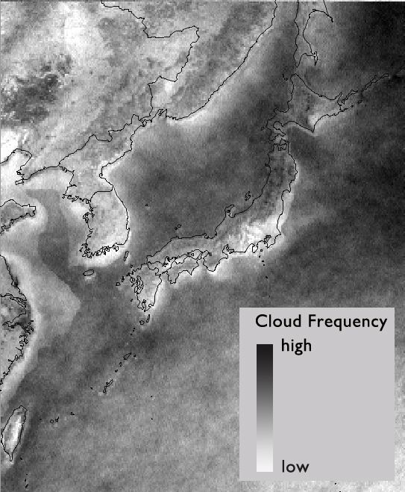

**Project Information**

* License: [Creative Commons BY-SA 3.0](http://creativecommons.org/licenses/by-sa/3.0/)
* Source Code/Project URL: <https://github.com/International-Space-Apps-Challenge-Tokyo/WhereToPutSolarPanels>

**Resources**

* Website (demonstration) - <http://solar-energy.no32.tk/>
* Dataset we use: MODIS Cloud Mask - <http://modis-atmos.gsfc.nasa.gov/MOD35_L2/>
* Analysis result data (CSV) of the cloud frequency - <https://github.com/International-Space-Apps-Challenge-Tokyo/WhereToPutSolarPanels/blob/master/mongo/japan_score_average_of_10_year.csv.zip>
* Discussion (in Japanese) - <https://www.facebook.com/groups/435555353200281/>
* An example image of the cloud frequency - <http://sphotos-e.ak.fbcdn.net/hphotos-ak-prn1/934798_552130204807786_1133548788_n.jpg>